1. Explain schema and instance with examples.

Schema
- Schema is the blueprint or structure of a database.
- It defines tables, attributes, and relationships.
Example:
Student(RollNo, Name, Department)

Instance
- Instance is the actual data stored in the database at a particular time.
Example:
RollNo | Name | Department
101 | Ravi | CSE
102 | Priya | IT

2. Identify the entities, attributes, and relationships for a Bank Management System and construct its ER diagram.

Entities
- Customer
- Account
- Branch
- Employee

Attributes
- Customer: Customer_ID, Name, Address
- Account: Account_No, Balance, Type
- Branch: Branch_ID, Location
- Employee: Employee_ID, Name

Relationships
- Customer owns Account.
- Branch maintains Account.
- Employee works in Branch.

Entities
- Customer
- Account
- Branch
- Employee
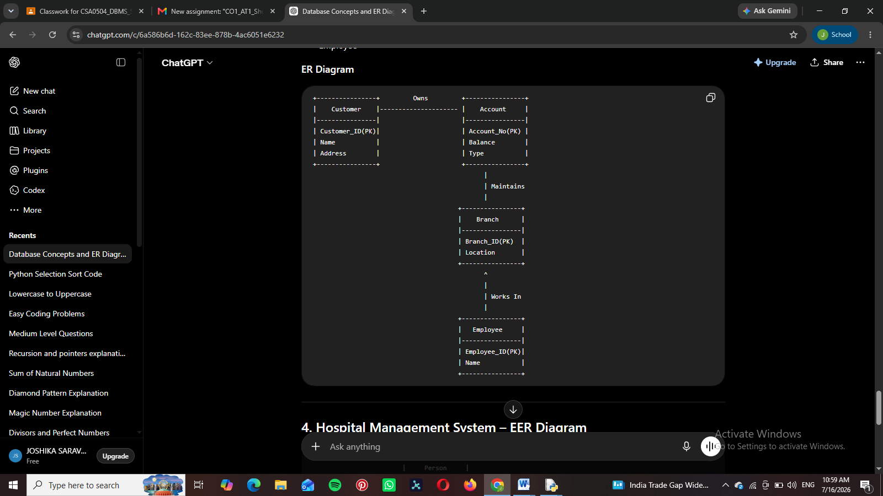

3. Explain the Extended ER (EER) model. Describe the concepts of generalization, specialization, and aggre

gation.

EER Model
The Extended Entity Relationship (EER) model is an advanced ER model that supports inheritance and complex relationships.

Generalization
Combines similar lower-level entities into one higher-level entity.

Specialization
Divides one entity into smaller specialized entities.

Aggregation
Treats a relationship between entities as a higher-level entity.

4. Design an EER diagram for a Hospital Management System incorporating inheritance and weak entities.
(Draw the EER diagram in the exam.)
Use these entities:
- Person
- Doctor
- Patient
- Hospital
- Medical Record (Weak Entity)
Relationships:
- Doctor treats Patient.
- Patient has Medical Record.
- Doctor and Patient inherit from Person.

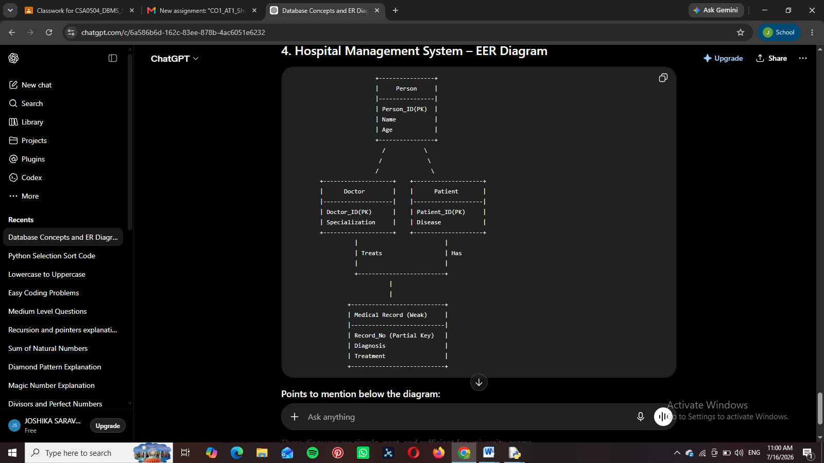

5. Explain the role of a DBA (Database Administrator) and the responsibilities associated with the position.

DBA
A Database Administrator (DBA) manages and maintains the database to ensure security, availability, and performance.

Responsibilities
- Create and maintain databases.
- Manage user access and security.
- Perform backup and recovery.
- Monitor database performance.
- Ensure data integrity.

